19, Unnati Amit Bank of Maharashtra Co Op Housing Society
Rasane Nagar, Savedi, Ahmednagar 414003.
Mobile No 089992 16015
aasawarizapake@gmail.com

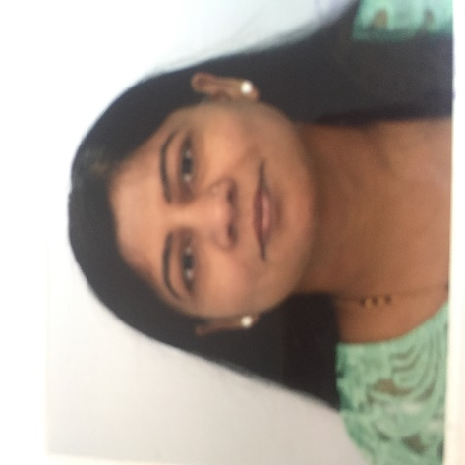

PERSONAL STATEMENT

A highly motivated & experienced individual. Rich experience in teaching field. International exposure of working with charitable organization old age people. Proven record of efficient, hardworking & sincere individual. Successfully managed to work in the teams with good inter-personal skills.

SKILLS

- Analytical Ability
- Multi-Tasking
- Leadership & Communication Skills
- Networking & organizational skills.

WORK EXPERIENCE

CSRD Institute of Social Work & Research, Ahmednagar – Asst Professor/ Teaching Associate (2017-2019)

Key Responsibilities:
- Teaching
- Fieldwork supervision
- Research guidance
- University Examination Paper Setting and Assessment
- Student Development Office Work

Evergreen Care Trust, Stamford, UK – Volunteer. (Oct 2012- Jan 2017)

I was associated with Evergreen care trust as a volunteer. I was engaged in different projects of the organization such as,

- Befriending.
- Hospital to home support.
- Administrative work.
- Community lunches.
- Fund raising activities and social events.

CSRD Institute of Social Work & Research, Ahmednagar – Asst Professor. (2004 – 2011)

Key Responsibilities:

- Teaching following subjects like,

- History and ideologies of Social work
- Personal Management.
- Labour Legislation in India.
- Employee Welfare.
- Administration and Management for Social Workers.
- Community Organization and social action

- Fieldwork Supervision: Fieldwork is an important part of academic curriculum which provides practical approach to social problems. Students are expected to gain a practical experience by working with different social areas. My role was to help students to understand the social problems, facilitate them to acquire practical knowledge in different social settings.

- Research Project Guidance: Every student under University of Pune has to undertake a research project related to the current social issues. My role as a faculty was to help the students to undertake the upcoming issues which require a serious attention & intervention. Enable them to understand the research activity, help them to develop research design, interview schedule & then to analyze the data statistically. Students undertake the research related to various social issues such as, health, women empowerment, child rights, labour problems, rural problems & problems of old age people etc.

- Supporting University sponsored projects: Every faculty working with University of Pune has to share the responsibilities to support University sponsored projects. These projects are carried out for the welfare of students. I was the in charge of Samarth Bharat Abhiyaan, Earn & Learn Scheme hence conducted various programs for the development of students.

- Participation in Government led social work projects: State Government projects were undertaken by the Institute in order to help the Government to formulate the social policies & programs. I had participated in various projects such as Sarva Shiksha Abhiyaan (Education for everyone), Total Sanitation Program and many other.

- University Examination Paper Setting and Assessment: As a teaching faculty, I shared a responsibility of Paper Settings & Assessment of University Examination.

- Arranging various seminars, workshop and Conference: For students’ development I organized various seminars & workshop at Institute level. As a team

- Assisting student selection process: Entrance test is a selection procedure for admitting new students for the MSW Course in any given academic year. As a team member helped the Institute to conduct the entrance test.

CSRD Institute of Social Work & Research, Ahmednagar – Visiting Faculty (2001-2004)

Subjects taught:
  - History and ideologies of Social work
  - Labour Legislation

BCC College of Social Work, Solapur, India – Lecturer. (1995 – 1997)

Key Responsibilities:
- Teaching
- Fieldwork supervision
- Research guidance

EDUCATION

- AIM Awards (United Kingdom) - Level 3 Certificate of counselling 2015-2016

- AIM Awards (United Kingdom) - Level 2 Certificate of counselling skills 2014-2015

- M. Phil - The Global Open University, Nagaland, India 2008 - 2010

- Master of Social Work - Shivaji University, Kolhapur, India 1992 - 1994

- Bachelor of Science (Chemistry) - Shivaji University, Kolhapur, India 1989 - 1992

Conference/ Seminar attended:

- International Conference on “Implications of Social Work Practice in Glocal World”, held on 14th & 15th December 2017 at Department of Social Work, St Joseph’s College, Bangalore Karnataka
- Two days National Seminar on “Social Work Practices in India: Innovations & Challenges”, on 24th & 25th February at CSRD-Institute of Social Work & Research, Ahmednagar
- 7th International Conference on Managing Human Resources at the Workplace on 14th and 15th December 2018 at Shri Dharmasthala Manjunatheshwara Institute for Management Development at Mysore.
Papers presented:

- “Loneliness & Social Isolation among Britain’s Elderly “, at International Conference on “Implications of Social Work Practice in Glocal World” held on 14th & 15th December 2017 at Department of Social Work, St Joseph’s College, Bangalore Karnataka
Articles Published:

- Prof Nilesh Gaikwad and Aasawari Zapake, (2017). Status, Position and conditions of women in India- Multidisciplinary International Conference on Women in Difficult Circumstances: Issues, Challenges and Responses organised by Samata Shikshan Sanstha Pune’s Dr. Babasaheb Ambedkar College of Social Work, Morane on 10-11 February 2017.

- Aasawari Zapake, (2016). Mental health at workplace- National conference on Emerging Trends for Excellence in Management and Information Technology organised by MIT College of Engineering, Centre for Management Studies and Research, Pune on 7-8 October 2016.

- Aasawari Zapake, (2016). Dr B R Ambedkar and labour welfare - National level Interdisciplinary Seminar on Dr B R Ambedkar’s contribution to Nation Building organised by Mahatma Fuley MSW and Matoshree Zaveriben Motilal Turkhiya BSW college, Taloda on 15th March 2016.
Participation in Seminar/Workshop as resource person: -
Special Lectures given: -

- Lecture conducted at IMSCDR for MBA 1st year students on Human Rights in Indian Context on 19th April 2018
Orientation/Refresher courses/ research methodology workshop attended:

- Seven days’ Workshop on Methodology of Social Science Research, 19th -25th June 2017
- Student Development Officer Orientation Workshop on 5th Jan 2018 organized at Arts, Science & Commerce College, Rahuri
- Central audit assessment pre-planning workshop on 9th March 2018 organized by Savitribai Phule Pune University, Pune
- Annual Planning Workshop organized by Student Development Board, SPPU, Pune on 30th August 2018

REFERENCES
  - References are available on request.

