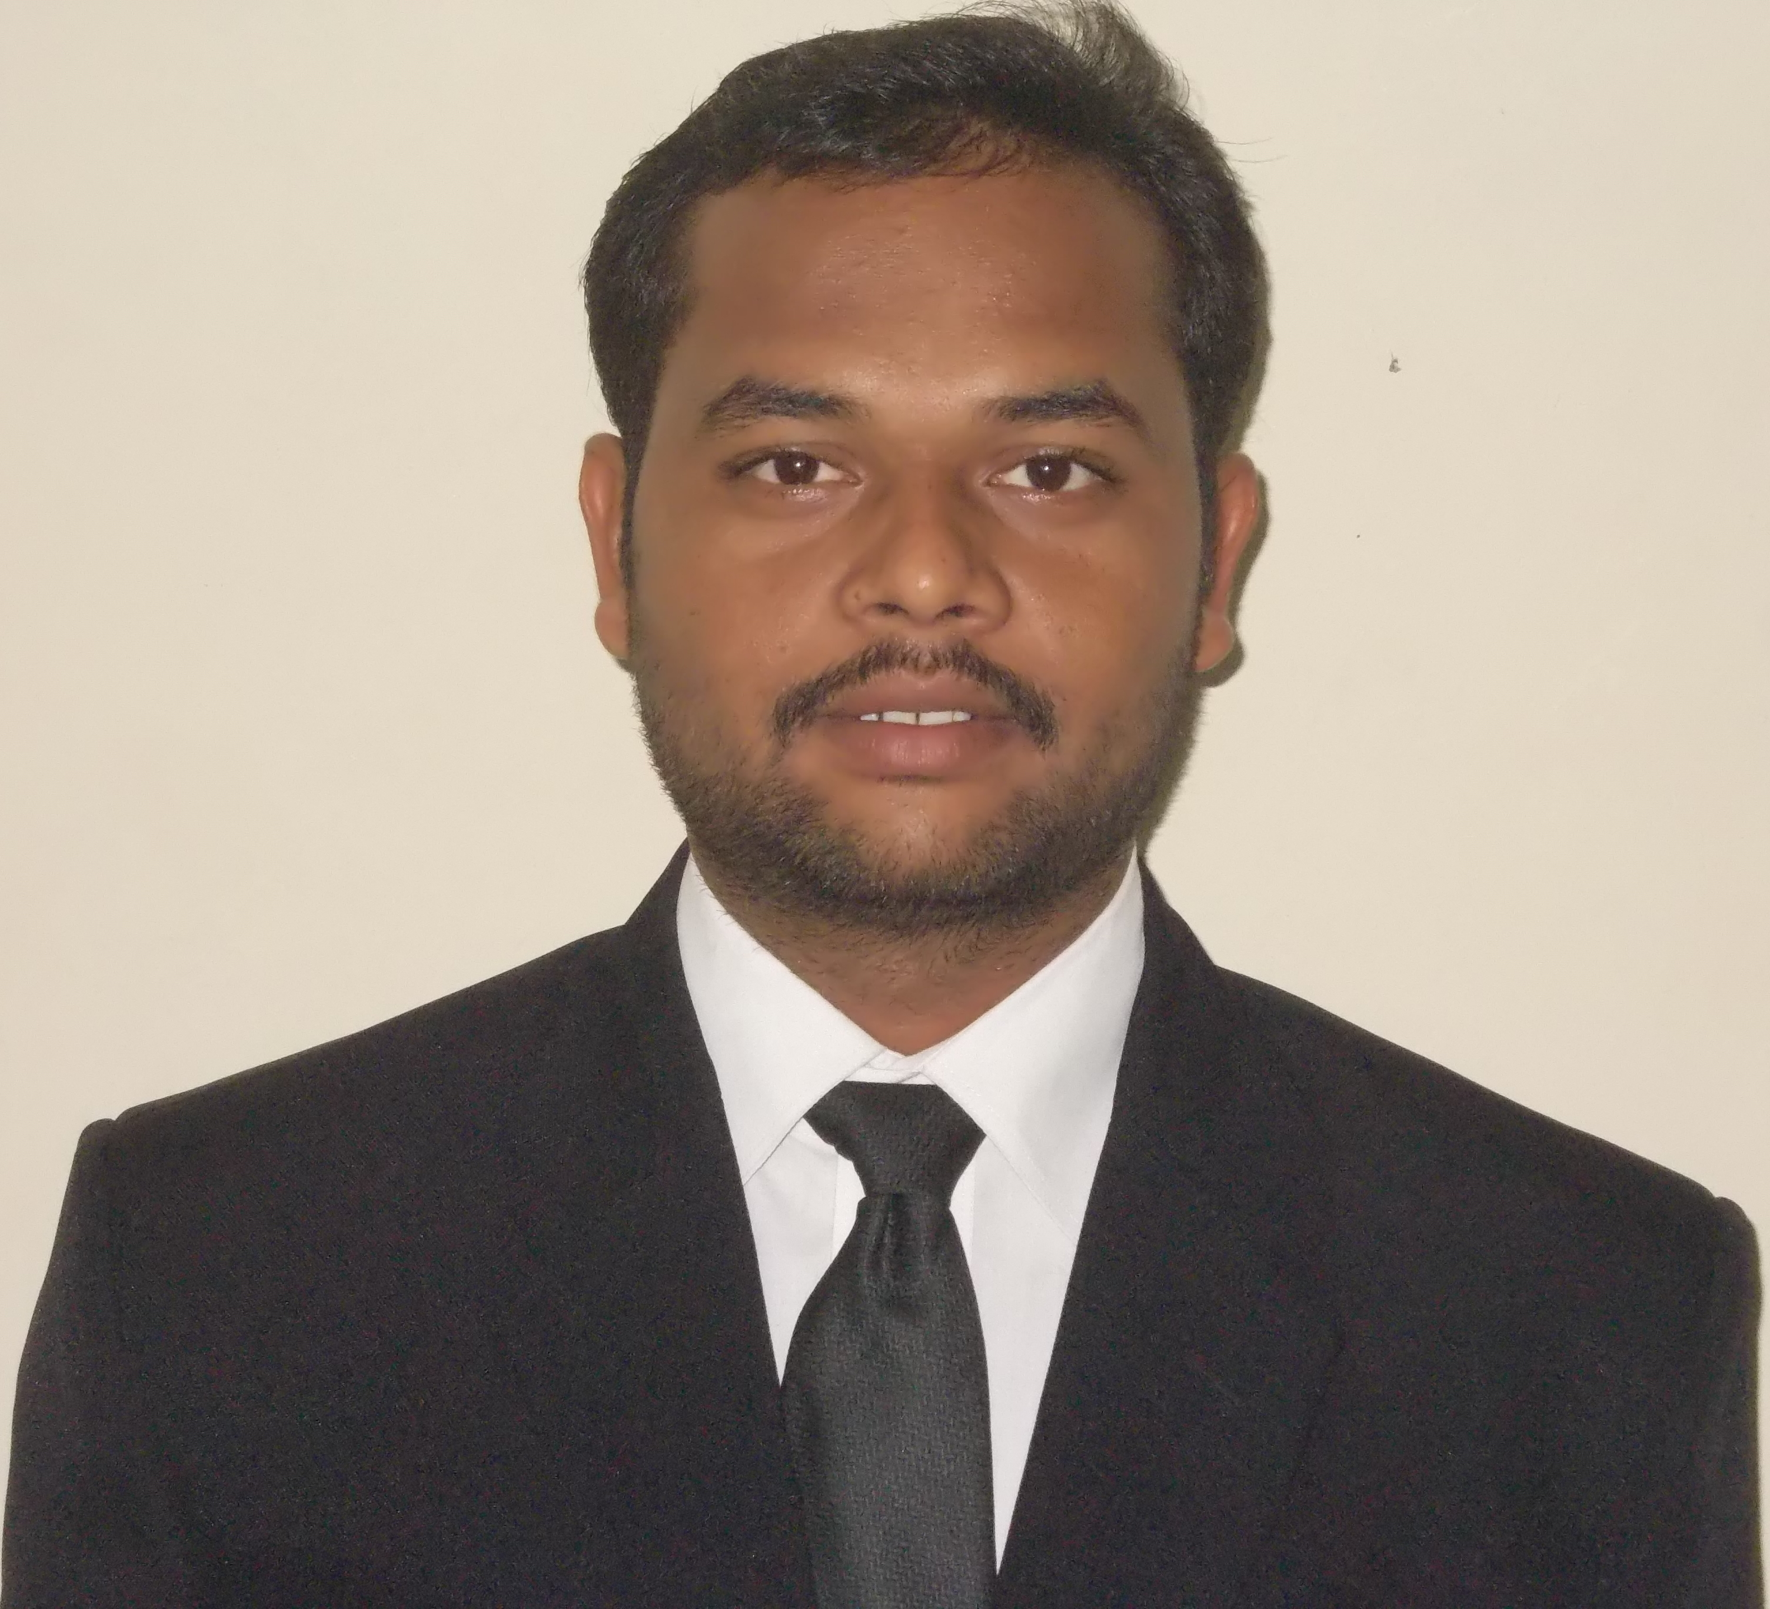
Name : Pradeep Jare
Contact No. : 08956981380
Email : pradeep.tiss@gmail.com

Current Position: Assistant Professor (Social Work, CSRD-ISWR, Ahmednagar, Maharashtra)

AREAS OF INTEREST:
- Contextualizing Social Work Education in India, Social Action as Method of Social Work
- Social Inclusion, Exclusion and Citizenship issues of Marginalised Sections in India
- Community Development with special focus on Education, Training, Research

ACADEMIC QUALIFICATION:

Qualification | Institution-University/Board | Year | Grade Points/ %
Ph.D (Pursuing) | Tata Institute of Social Sciences, Mumbai, India | 2017 | Pursuing
UGC-NET | University Grant Commission | 2011 | Qualified
M.A. Social Work | Tata Institute of Social Sciences, Mumbai, India | 2011 | G.P.A.  4.67(A)
B.A. in Social Work with specialization in Rural Development (Hons.) | Tata Institute of Social Sciences, School of Rural Development Tuljapur, Maharashtra, India | 2008 | G.P.A  4.60 (A)

Attendance in Academic Required Course:
Attended 48th Orientation course organized by Jawaharlal Nehru Technological University, Hederabad, Telangana, (December 2017)

PROFESSIONAL/ WORK EXPERIENCE:

- Subjects Taught at PG level:

- Dalit and Tribal Social Work (Sem-IV
- Community Work Sectors and Interventions (Sem-IV)
- Social Policy in India (Sem-III)
- Social Sciences for Social Workers (Sem: I)
- Governance and Community Development (Sem: II)
- Family Life Education and Population Studies (Sem-III)
- Planning and Management of Community Projects (Sem-IV)

.
Name of the Organization | Designation | Nature of work | Duration
CSRD- Institute of Social work and research, Ahmedanagar | Assistant Professor | - Engaging Lectures  - Field work Coordination and Supervision  - Placement Cell Coordinator  - Research guidance for post graduate students  - Research and Extension | Since July 2012
CSRD- Institute of Social work and research, Ahmedanagar | Teaching Associate | - Engaging Lectures  - Teaching Programme Coordinator (IGNOU)  - Field work Supervision  - Research guidance for post graduate students | June 2011-May 2012
Society to Heal, Aid, Restore and Educate (SHARE), CSR, UTV. | Social Worker | - Awareness about NRHM in community  - Conducting sessions with primary school children  - Rain Water Harvesting  - Formation of SHGs | 2008-2009

OTHER EXPERIENCE:

Name of the Organization | Designation | Nature of work | Duration
AFPRO, Ahmednagar | Team member | Impact assessment of projects implemented in tribal communities of Dadra-Nagar Haweli | January 2019 to March 2019
CSRD, Social Justice Dept, Ahmednagar | Trainer | Training to Police officers, Gramsevaks, Sarpanch, and other village development officials about Prevention of SC/ST Atrocity Act | April 2011-  June 2011
Christian Auxiliary Social Action (CASA), Maharashtra. | Resource  Person | Data entry and interpretation of survey data collected by agency. | Short Duration(One week)
TISS, Tuljapur, Maharashtra. | Campaign  Organizer | Worked on a Project - NREGA & RTI Awareness, through Street Play, Community Meetings. | One Month
MAVIM (State Govt.), Osmanabad, Maharashtra | Research  Investigator | Impact evaluation study of MAVIM SHGs Programme | One Month
Tata Institute of Social Sciences (TISS), Rural Campus, Maharashtra | Campaign  Organizer | Organised the Total Sanitation Campaign (TSC) as a part of field action programme of TISS, RC, Tuljapur. | One Week
MKSS, Baswanda, Rajasthan. | Volunteer | Participated in NREGA Social Audit Campaign. | Short Duration (12 days)
India Social Forum, New Delhi | Volunteer | Worked as Volunteer of NACDOR organization  Performed a Street play in the forum. | Short Duration  (5 days)

Papers Published:
- Jare Pradeep, Development Under the Threat of Caste Atrocities in Post-Colonialism (Study of Caste Atrocities on Dalits and its Impact on their participation in Public Sphere), in edited book “ Caste in Modern India: Atrocities Against Dalits, Jare R & Kale S, 2017, Studium Press (India), ISBN: 978-9385046-11-7

- Jare Pradeep, Social Exclusion and Citizenship Issues on Pardhis, in edited book “Social Justice and Social Work Profession in India: Challenging Responses and Responding Challenges, Suresh Pathare, Sanjai Bhatt, Jaimon Varghese, 2016, ISBN: 978-93-83231-30-0

Conference/Seminar:
- Presented a paper on ‘Structural Social Work: An Indigenous Approach to Social Work with Margnisalised Communities in Indian Context’ in National Seminar organized by Jamia Millia Islamia (November 2018)
- Participation in National Symposium Competencies, Compassion and Commitment organized by CSRD-ISWR, Ahmednagar (MS) (April 2017)
- Presented a paper on ‘Structural Social Work- (E)merging area in Social Work Education and Social Justice: A Perspective from Within’ in 4th Indian Social Work Congress organized by MG Kashi Vidyapith & NAPSWI
- Participated in State Seminar on Rural Development organized by CSRD-ISWR (March 2016)
- Presented a paper in National Seminar on Social Exclusion: Prospective and Challenges on ‘Inclusion of Dalit women through Structural Social Work: Perspective from below’ organized by Tilak Maharashtra University, Pune (March 2016)
- Participated in 5th International Conference on Community Engagement for Sustainable Development organized by CSRD-ISWR, Ahmednagar, MS (February 2016)
- Presented paper in 3rd Indian Social Work Congress on Indigenization of Social Work through Social Action in Indian Context organized by Jain Vishwa Bharati, Ladnun & NAPSWI (October 2015)
- Presented a paper in National Conference on Exclusion and Atrocities on Dalits in India on Development Under the Threat of Caste Atrocities in Post-Colonialism (Study of Caste Atrocities on Dalits and its Impact on their participation in Public Sphere) organized by TISS, SRD, Tuljapur (June 2015)
- Presented a Paper in 2nd Indian Social Work Congress on Social Exclusion and Citizenship Issues of Pardhi Community organized by NAPSWI 7 CSRD-ISWR (December 2014)
- Presented a paper in International Conference on Mainstreaming and Inclusion of Dalit Women for Equitable Society through Political Justice organised by CSRD-ISWR, Ahmednagar (March 2014)
- Participated in Second International Conference on Spirituality and Social Work Organised by CSRD (January 2013) (Organising Committee Member)
- Participated in 10th National Seminar on Quality of Education in Social Work organized by Central university of Kerala
- Participated in National Seminar on Community Development, Social Work and HIV/AIDS organised by Vishwa Bharti, Shantiniketan and IGNOU (January 2012)
- Participated in International Conference on Religion, Spirituality and Social Work organised by CSRD-ISWR, Ahmednagar (December 2011)
- Attended a Regional conference on Inclusion and Exclusion organized by Karve Institute of Social Sciences, Pune, India
Administrative Tasks:
- Coordinator: Fieldwork Office, CSRD-ISWR
- Coordinator – Career Guidance and Placement Cell, CSRD-ISWR
Membership:
- Member, National Association of Professional Social Workers in India (NAPSWI)
- Founding Member, Social Workers Action for Rural Development (SWARD)
PERSONAL PROFILE:

Sex : Male
Date of Birth : 9th May 1987

CONTACT DETAILS:
Mob: 08956981380

Email id: pradeep.tiss@gmail.com

Address for communication:

Permanent Address:  Karmveer Nagar, Indiara Path, Kopergoan  Dist. Ahmednagar,  Pin: 423601  Maharashtra, India. | Correspondence Address:  CSRD- Institute of Social Work and Research,  Station Road, Ahmednagar.  Maharashtra. 414001

